**PIZZA SALES SQL QUERIES**

**A. KPI’s**

**1. Total Revenue:**

SELECT SUM(total_price) AS Total_Revenue FROM pizza_sales;

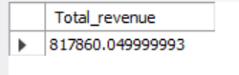

2. Find the average order value

SELECT (SUM(total_price) / COUNT(DISTINCT order_id)) AS Avg_order_Value FROM pizza_sales;

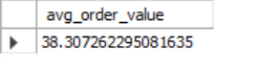

**3. Total Pizzas Sold**

SELECT SUM(quantity) AS Total_pizza_sold FROM pizza_sales;



**4. Total Orders**

SELECT COUNT(DISTINCT order_id) AS Total_Orders FROM pizza_sales;



**5. Average Pizzas Per Order**

SELECT CAST(CAST(SUM(quantity) AS DECIMAL(10,2)) /

CAST(COUNT(DISTINCT order_id) AS DECIMAL(10,2)) AS DECIMAL(10,2))

AS Avg_Pizzas_per_order

FROM pizza_sales;



**B. Daily Trend for Total Orders**SELECT DATENAME(DW, order_date) AS order_day, COUNT(DISTINCT order_id) AS total_orders

FROM pizza_sales

GROUP BY DATENAME(DW, order_date)

***Output:***

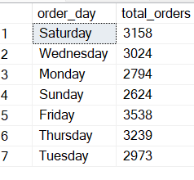

**C. Monthly Trend for Orders**

select DATENAME(Month,order_date) as months_name, COUNT(DISTINCT order_id) as total_orders

from pizza_sales

group by DATENAME(Month,order_date)

order by total_orders desc;

***Output:***

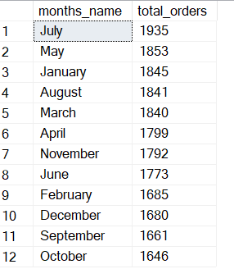

D.Percentage of sales by pizza category

SELECT pizza_category, CAST(SUM(total_price) AS DECIMAL(10,2)) as total_revenue,

CAST(SUM(total_price) * 100 / (SELECT SUM(total_price) from pizza_sales) AS DECIMAL(10,2)) AS PCT

FROM pizza_sales

GROUP BY pizza_category;

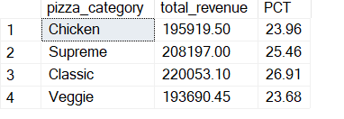

**E. % of Sales by Pizza Size**

select pizza_size, cast(sum(total_price) as decimal(10,2)) as total_revenue,

cast(sum(total_price) * 100 /(SELECT SUM(total_price) from pizza_sales) AS DECIMAL(10,2)) AS PCT

FROM pizza_sales

GROUP BY pizza_size

ORDER BY pizza_size;

Output

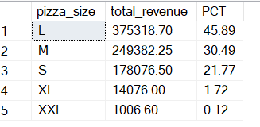

**F. Total Pizzas Sold by Pizza Category**

select pizza_category, sum(quantity) as total_quantity_sold from pizza_sales

group by pizza_category

order by total_quantity_sold desc;

output

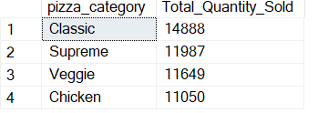

**G. Top 5 Pizzas by Revenue**

select top 5 pizza_name, sum(total_price) as Total_revenue

from pizza_sales

group by pizza_name

order by Total_revenue desc;

Output

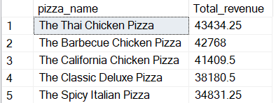

**H. Bottom 5 Pizzas by Revenue**

select top 5 pizza_name, sum(total_price) as Total_revenue

from pizza_sales

group by pizza_name

order by Total_revenue asc;

output

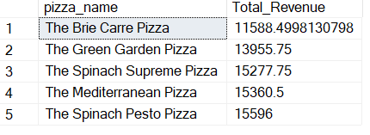

**I. Top 5 Pizzas by Quantity**

select top 5 pizza_name, sum(quantity) as total_order_sold

from pizza_sales

group by pizza_name

order by total_order_sold desc;

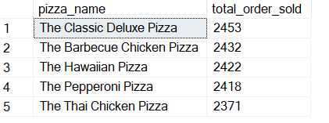

**J. Bottom 5 Pizzas by Quantity**

select top 5 pizza_name, sum(quantity) as total_order_sold

from pizza_sales

group by pizza_name

order by total_order_sold asc;

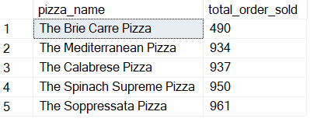

**K. Top 5 Pizzas by Total Orders**

select top 5 pizza_name,count(distinct order_id) as Total_orders

from pizza_sales

group by pizza_name

order by Total_orders desc;

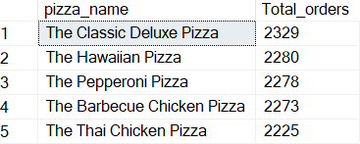

**L. Borrom 5 Pizzas by Total Orders**

SELECT Top 5 pizza_name, COUNT(DISTINCT order_id) AS Total_Orders

FROM pizza_sales

GROUP BY pizza_name

ORDER BY Total_Orders ASC;

